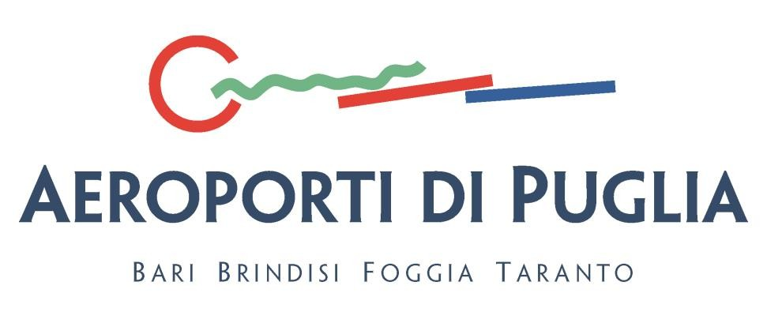

Commercial Policy for the Development of Aeroporti di Puglia Network
ANNUAL PROGRAM FOR INCENTIVES

Aeroporti di Puglia traffic development through new air routes to be activated within Summer 2018 IATA Season

Aeroporti di Puglia S.p.A., pursuant to the Italian Ministry of Infrastructure and Transportation guidelines issued on October 2, 2014, and to “Operating Regulations” issued on December 23, 2014, by ENAC-Italian Civil Aviation Authority, with regard to transparency, fair competition and non-discriminating policies, within its mandate to foster enterprise initiatives, aims at promoting direct (point-to-point) domestic, international and inter-continental flights which, based on documented financial evaluations, may increase the development of its airports’ business and improve Puglia Region’s transport connections.

Said development can be achieved through new direct intercontinental routes, connections to major European hubs, a greater number of short and medium-haul European and Mediterranean destinations, and through the reduction of the strong seasonal character of Apulian airports.

This document aims at making public, in a transparent fashion and safeguarding equal opportunities for concerned carriers, the incentives Program Aeroporti di Puglia S.p.A. intends to activate in view of the forthcoming the IATA Summer 2018 season, based on which there will be the signing of incentives agreements with carriers that will significantly contribute to the growth of the Apulian airport system by introducing new scheduled routes and/or significantly increasing existing ones.

Program Targets

Through this program, Aeroporti di Puglia S.p.A. aims at achieving the following targets:

- Increase intercontinental connections of Apulian airports, through direct flights and better Hub carriers’ services towards own Hubs;

- Increase point-to-point connections, or the number of served domestic and European routes;

- Desasonalize traffic across Apulian airports;

Connection Categories

Aeroporti di Puglia Incentives Program entails the following 5 connections categories:

  - New intercontinental routes;

  - New connections to Hubs with carriers having their Hub in the connected airport, or commercial agreements allowing passengers to benefit from connecting flights;

  - New European and Mediterranean “Strategic” point-to-point routes, which are of great interest for Apulian airports based on its own evaluations of potential traffic demand;

  - New European and Mediterranean “interesting” point-to-point routes for Apulian airports.

  - Deseasonalize, meaning to increase offer over the October-May period on existing routes by already operating carriers.

Incentives
Aeroporti di Puglia S.p.A., within its mandate of opening to free entrepreneurial initiative its incentives policy by selecting professional beneficiaries, has the right to identify carriers and distribute premiums, as well as additional incentives, related to the total number of passengers (new or additional) relevant to the routes subject to this agreement, according to the following conditions.

- Upon signing the incentives agreements, the incentive amount will be granted taking into consideration the following:

- the number of routes established in the agreement and proposed in the comprehensive Development Program submitted by the carrier to Aeroporti di Puglia S.p.A. (hereafter “Development Program”);

- the total number of additional seats on the agreement’s established routes, based on the carrier’s Development Program;

- market’s penetration, that is the number of served routes by the new airport(s) to be connected, and identified by the carrier in the Development Program, thus proving its entrepreneurial capabilities on the specific market;

- the seasonal character of proposed routes in the Development Program;

- the type of aircraft that the carrier intends to use in carrying out the Development Program.

Program Participation Prerequisites

Aeroporti di Puglia S.p.A. aims at commissioning services to Air Carriers possessing the necessary technical-organizational and financial-economical prerequisites, in order to duly carry out assigned activities. Interested operators must possess the hereafter listed prerequisites, which must be in place upon offer’s submission:

  - Air Service license and authorization issued by pertaining EU Member state, pursuant to EU Regulation n. 2407/92, as published in the European Union Official Journal on August 24, 1992, and updated by EU Regulation n. 1008/2008;

  - Air Operator Certificate (AOC), or other similar certificate stating the authorization to operate as air carrier and issued by carrier’s Country of origin authorities;

In case the air carrier is not based in the European Union, appropriate prerequisites will be further evaluated.

Application Instructions

Interested air carriers must submit their expression of interest, including a written proposal with a description of air routes. In order to comply with fair competition policies, please be advised that proposals related to the same routes will be compared and evaluated in order to assess the best offer. The proposal must be submitted together with a business plan proving the effective profitability of the air routes for both parties. As regards not yet operated “point-to-point” domestic and international routes, and/or new flights through already operating ones, which may produce improved connections and increased passengers volumes to and from Apulian airports, there shall be the application of general and economical requirements as mandated by the European Commission Communication “Guidelines on State Aids to Airports and Airlines” (2014/C 99/03), published in the European Union Official Journal, issue C99/3, April 4, 2014.
The expression of interest must be submitted in writing to Aeroporti di Puglia S.p.A. through certified e- mail, at this address: ufficioprotocollo@pec.aeroportidipuglia.it. In case of application from abroad, the economic operator that is not using a certified e- mail system, may send its application via Fax to the following number : 0039080 5800225 , attention to: “Ufficio Protocollo di AdP.”
Interested companies, by submitting their expression of interest, hereby agree to handling of their personal data according to Italian Legislative Decree D. Lgs. 196/2003 for the duration of scrutiny operations. It is hereby stated that Air Carriers, by simply submitting their expression of interest, may not lay claims, nor call for any right or preference regarding the attainment of incentives. Aeroporti di Puglia S.p.A. holds full power of assigning incentives, with reference to routes on which no offer has been submitted, to air carriers who have expressed their interest also in other air routes, which may be in the interest of this Company.

