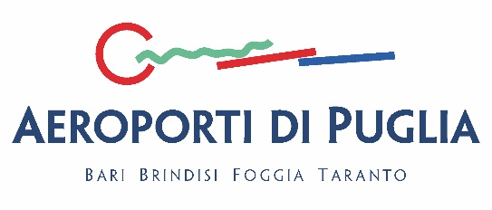

CONFIDENTIALITY AGREEMENT

The Company/Association ___________________________________(hereinafter referred to as the "Company") represented herein
by______________________________________ born in _________________ on_______________
Tax Code_______________________(attach identification document), role ___________________
(if different from the Legal Representative, attach power of attorney), acknowledges and declares that it is aware that the documentation made available by the airport operator (hereinafter "AEROPORTI DI PUGLIA") relating to the Consultation on the tariff proposal for the period 2025-2027, corrected in accordance with point 1 of ART Resolution No. 88/2025 of the Users of Aeroporti di Puglia S.p.A. (Bari, Brindisi, Foggia, Grottaglie), is strictly confidential pursuant to and for the purposes of point 3 of chapter 6.4.1. of the Tariff Models referred to in ART Resolution No. 38/2023 and may not therefore be communicated to third parties and/or disclosed, except as expressly indicated below.

To this end, it acknowledges that all data and information acquired constitute the corporate assets of
AEROPORTI DI PUGLIA and must therefore be treated with the utmost confidentiality and in the sole and exclusive interest of AEROPORTI DI PUGLIA itself.

The Company/Association also undertakes to use such information solely and exclusively for the purposes of
Consultation by Users and consequently undertakes to:
• not to communicate to third parties and/or disclose any confidential information, unless with the prior written consent
of AEROPORTI DI PUGLIA;
• not to issue statements, interviews or press releases that contain, even if only
occasional or marginal, the confidential information of AEROPORTI DI PUGLIA;
• not to mention such confidential information in publications, documents, deeds or channels of
communication channels intended for public dissemination.

The Company/Association guarantees the protection of the confidentiality of AEROPORTI DI PUGLIA's confidential information and the treatment of matters relating to the activities of AEROPORTI DI PUGLIA that it uses in relation to its own confidential information and data.

Finally, the Company/Association acknowledges that AEROPORTI DI PUGLIA has the right to take action in the appropriate forums to protect its interests in the event of a breach of this confidentiality agreement.

Stamp and legal signature of representative or attorney

